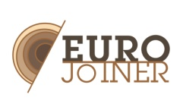
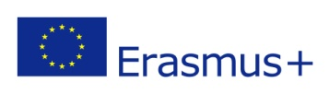
EUROJOINER
Mobility of Wood Workers (joiners/carpenters) across Europe
2015-1-ES01-KA202-015902

ERASMUS+
KA2 - Cooperation for innovation
and the exchange of good practices
KA202 - Strategic Partnerships for vocational education and training

Invitation / Uitnodiging Rotterdam, 28-4-2017

Dear Mrs, Mr.

On behalf of all partners in the EUROJOINER project,
the HMCollege for Wood, Furniture and Interior has the pleasure to invite you for the

MULTIPLIER EVENT that will take place on Thursday May 11, 2017
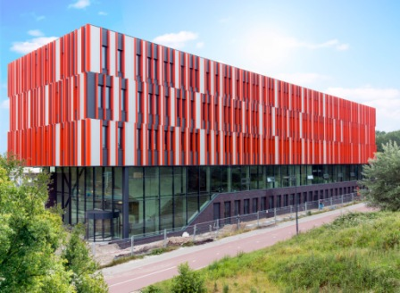
from 14.00- 17.00

at the HMC vocational training school, location Rotterdam
Erasmuspad 10, 3052KP Rotterdam, The Netherlands

The event will inform you about development and results of this EUROJOINER project.
The project aims to facilitate the development of a qualification for joiners at European level, in order to facilitate the mobility of workers and students in this sector.
We will present
- an overview over the project,
- explain the unified joiner profile based on the professional situation and education in the
participating partner countries,
- present the training material developed for the Moodle platform,
- future steps in the project

The partners will each present their institutions in short presentations. These partners are Aidimme (Spain), Woodwize (Belgium), CFPIMM (Portugal), CIP Cattaroja (Spain) , Kayseri (OSB METEM (Turkey), Amledo (Sweden) an HMC (Netherlands). For more information on the project you can visit our website www.eurojoiner.com

You will have the chance to meet the representatives of these institutions, exchange ideas about the development of European common profiles, discuss woodworkers competences and skills needed in the European Union and the challenges presented by a greater mobility of workers, students and production facilities in the field of joinery.

We will be most happy to receive you at our multiplier event and kindly ask you to notify your presence by sending an email with:
your name, the organization you work for, your e-mail address and mobile phone number
to:
j.leijtens@hmcollege.nl

Note
We can reimburse your travel costs .If you would like to come earlier on the day to have a more extensive round tour at HMC than the one included in the program please inform us in time.

Arrival by train: from Rotterdam Central Station, take Metro E, direction Den Haag,
second stop Melanchtonweg. You will see the HMC building next to this station.

